J’apprends le français
Vocabulary Bank: Greetings  Bonjour – Good morning  Salut - Hi  Au revoir - Goodbye  Plus tard – See you later |  | Vocabulary Bank: Colours
 |  | bleu | noir | marron | jaune | rouge
 |  | gris | vert | blanc | violet | orange
Questions and Answers  Comment t’appelles-tu? – What’s your name?  Je m’appelle... – My name is...  Quel âge as-tu? – How old are you?  J’ai ____ ans. – I am ____ years old.  Ça va? – How are you?  Ça va bien. – I’m fine.  Ça va mal. – I’m not good at all.  Comme çi, comme ça. – Not bad. Okay.  Et toi? – And you? |  | Vocabulary bank: Numbers  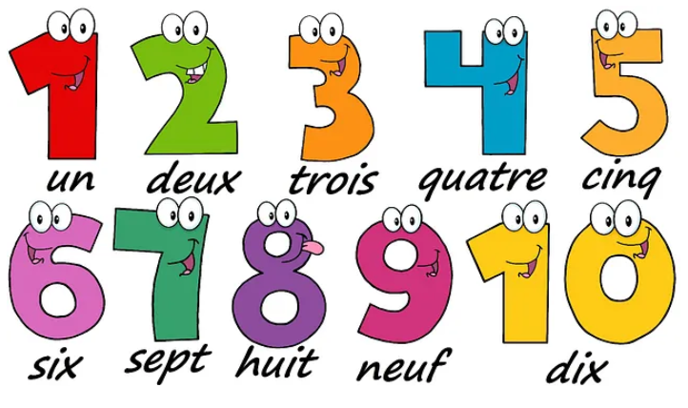
Phonics Bank – In this unit we will see:  - oi sound in ‘trois’ and ‘noir’  - on sound in ‘marron’  - ou sound in ‘rouge’ |  | Silent Letters  There are many last consonant silent letters in French. The final letter ‘s’ is silent in the words  ‘trois’ and ‘gris’. The final ‘t’ is silent in ‘vert’ and ‘violet’.
La phonétique
In this unit we will learn a selection of the key phonemes to help us with our French pronunciation.
mouton  (like ‘oo’ in ‘tooth’)  sheep | musique  (like ‘eek’ in ‘week’)  music | yeux  (like ‘euuhh’ in ‘bird’)  eyes
cochon  (like ‘onn’ in ‘honk’)  pig | famille  (like ‘eeyeh’ in ‘yes’)  family | quatre  (like ‘c’ in ‘cook’)  four
cheval  (like ‘sh’ in ‘shop’)  horse | café  (like ‘eh’ in ‘set’)  cafe | campagne  (like ‘nyuh’ in ‘onion’)  countryside
oiseau  (like ‘wah’ in ‘waffle’)  bird | règle  (like ‘ai’ in ‘air’)  ruler | français  (like ‘ss’ in ‘say’)  French
six  (like ‘ee’ in ‘see’)  six | appartement  (like ‘euh’ in ‘the’)  flat | dents  (like ‘on’ in ‘song’)  teeth
cinq  (like ‘an’ in ‘clang’)  five | bureau  (like ‘oh’ in ‘all’)  office | blanc  (like ‘on’ in ‘song’)  white

En classe
Vocabulary Bank: Classroom objects  un livre – a reading book  un cahier – an exercise book  un crayon – a pencil  un stylo – a pen  un taille-crayon – a sharpener  un sac à dos – a rucksack  un bâton de colle – a glue stick  une calculatrice – a calculator  une règle – a ruler  une gomme – a rubber  une trousse – a pencil case  des ciseaux – a pair of scissors |  | Phonics Bank – In this unit we will see:  - i sound in ‘livre’, ‘calculatrice’ and ‘ciseaux’  - silent letters – when ‘s’ or ‘x’ is the final consonant, it is nearly always a silent letter in French, e.g. you do not hear the letter ‘s’ in the word ‘des’ or the ‘x’ in ‘ciseaux’  - elision – This is a type of contraction. The last letter of a word is dropped and replaced with an apostrophe. It is attached to the word that follows beginning with a vowel.  Examples: je becomes j’ as in j’ai.  ne becomes n’ as in n’ai.
Vocabulary Bank: ‘my’  mon - my (masculine singular nouns)  ma - my (feminine singular nouns)  mes - my (all plural nouns)  Dans ma trousse j’ai mon cahier, ma règle et mes ciseaux. |  | Grammar Bank  - possessive pronouns – to know which form of the possessive pronoun ‘my’ to use according to whether the noun is masculine or feminine, singular or plural  le cahier – mon cahier  la règle – my ruler  des ciseaux – mes ciseaux  - the negative structure ‘je n’ai pas de’…  e.g. J’ai une gomme. I have a rubber.  Je n’ai pas de gomme. I do not have a rubber.  - coordinating conjunctions – using ‘et’ (and) to write longer sentences
Questions and Answers
Qu’est-ce qu’il y a dans ta trousse?
What do you have in your pencil case?
Dans ma trousse j'ai... – In my pencil case I have...
Dans ma trousse je n'ai pas de... – In my pencil case I do not have...
As-tu un animal?

Vocabulary Bank: Pets  un chien – a dog  un chat – a cat  un lapin – a rabbit  un hamster – a hamster  un poisson rouge – a goldfish  un oiseau – a bird  une souris – a mouse  une tortue – tortoise  qui s’appelle – that is called  et – and  mais – but |  | Phonics Bank – In this unit we will see:  - e sound in ‘je’ and ‘de’  - eau sound in ‘oiseau’  - é sound in ‘Cécile’  - silent letters – the final letters ‘s’ and ‘t’ are not pronounced in, e.g. ‘souris’ and ‘chat’  - ‘h’ aspiré – this type of ‘h’ is not pronounced, but still acts like a consonant  - elision, e.g. 'Je n’ai pas d’oiseau'. This is the dropping of the last letter of a word (in this case the ‘e’ in ne and de) and replacing it with an apostrophe. This is then attached to the word that follows, which will begin with a vowel.
Questions and Answers  As-tu un animal? Do you have a pet?  J’ai un hamster. I have a hamster.  Je n’ai pas d’animal. I don’t have a pet.  As-tu un chien? Do you have a dog?  Oui, j’ai un chien. Yes I have a dog.  Non, je n’ai pas de chien. No I don’t have a dog.  J’ai un chien qui s’appelle Lottie.  I have a dog that is called Lottie. |  | Grammar Bank  - determiners – un (masculine) and une (feminine)  - high frequency verbs:  j’ai  je m’appelle  je suis  - the negative structure: je n’ai pas de/d…  je n’ai pas de + word beginning with a consonant  je n’ai pas d’ + word beginning with a vowel

